14.3 Partial Derivatives — Meaning and Notation
Recall: A partial derivative measures slope when one input changes and the other is held fixed.
$$f_{x}(x,y) = \frac{∂f}{∂x} f_{y}(x,y) = \frac{∂f}{∂y}$$
$fₓ$ is the slope in the x-direction (hold y constant).
$f_{y}$ is the slope in the y-direction (hold x constant).

Entry Task
Let $f\left(x,y\right)= 15-x² - y²$
and find the $f_{x}(7,4)$ and $f_{y}(7,4)$ .

Visualizing slopes on a surface
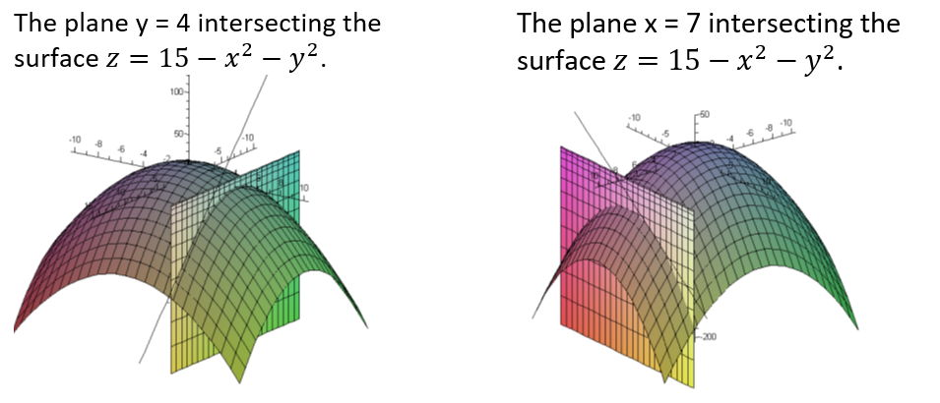
https://www.desmos.com/3d/esqi9npfuf

Second Partial Derivatives
2nd deriv. describe how the 1st deriv. change:
Concavity:
$$f_{xx}=\frac{∂}{∂x}\left(f_{x}\right) , f_{yy}=\frac{∂}{∂y}(f_{y})$$

Example: Find all first and second partials of
$$f\left(x,y\right)= x² - y²$$

https://www.desmos.com/3d/kjk9bvrczo
Clairaut’s Theorem: If the mixed second partials are continuous near the point, then $f_{xy}=f_{yx}$at that point.
Mixed Partials
$$f_{xy} =\frac{∂}{∂y}\left(f_{x}\right) , f_{yx} =\frac{∂}{∂x}\left(f_{y}\right)$$

Example: Find all four second partial derivatives for
$$f(x,y) = x⁴ + 3x²y³ + y⁵$$

https://www.desmos.com/3d/abxxggcw1k
Computing Partial Derivatives · HW Part 1 Q3–8
Use the same differentiation rules as Calculus I. The other inputs are constants.
Example 1: Quotient Rule HW Q4
$$w(u,v) =\frac{eᵛ}{u + v^{6}}$$
Find $\frac{∂w}{∂u}$ and $\frac{∂w}{∂v}$

Example 2: Three Variables HW Q8
$$u(x,y,z) =4x^{y/z}$$
Find $u_{x},$ $u_{y}$, and $u_{z}$.

Calculus - Summary of Derivatives
A variable may be treated as:
1. A constant
2. An independent variable (input)
3. A dependent variable (output)
Example 1: $y=x^{2}$, find $\frac{dy}{dx}$.

Example 2: An object location is given by $(x(t),y(t))$ and always moves along the curve $y=x^{2}$, find $\frac{dy}{dt}$.

Example 3: $x² + xy² = 1$. Find $\frac{dy}{dx}$

Example 4: $z = x² + y³ - 5xy⁴$
Find $\frac{∂z}{∂x}$ and $\frac{∂z}{∂y}$ .

Example 5: $x² + xy² - z² = 1$
Find $\frac{∂z}{∂x}$ and $\frac{∂z}{∂y}$

Interpreting Partial Derivatives HW(2) Q1–3, 8–9
At a given point on a surface, what do the signs of fₓ and fᵧ tell us?
Positive:
increasing height in the positive coordinate direction.
Negative:
decreasing height in that direction.
Second partials:
concavity along coordinate directions;
Mixed partials:
how one slope changes as the other coordinate varies.

App: Temperature on a Plate · HW(2) Q8
$T(x,y) = 65/(3 + x² + y²)$ degrees Celsius
At (2,3), find the rate of temperature change in the x-direction and in the y-direction. Include units.

